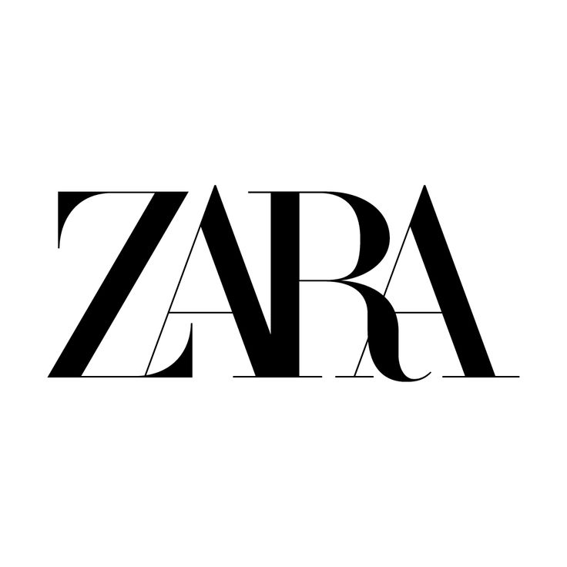

**ZARA Retail Pvt Ltd**

# **Product Dissection for Zara**

**Company Overview:**

Zara is a [fast fashion](https://en.wikipedia.org/wiki/Fast_fashion) retail [subsidiary](https://en.wikipedia.org/wiki/Subsidiary_company) of the Spanish multinational fashion design, manufacturing, and retailing group [Inditex](https://en.wikipedia.org/wiki/Inditex). Zara sells clothing, accessories, beauty products and perfumes. The head office is located at [Arteixo](https://en.wikipedia.org/wiki/Arteixo" \o "Arteixo) in the [province of A Coruña](https://en.wikipedia.org/wiki/Province_of_A_Coru%C3%B1a), Spain. In 2020 alone, it launched over twenty new product lines.

Zara was established by Amancio Ortega Gaona in 1975. Their first [shop](https://en.wikipedia.org/wiki/Clothes_shop) was in central [A Coruña](https://en.wikipedia.org/wiki/A_Coru%C3%B1a), in [Galicia](https://en.wikipedia.org/wiki/Galicia_(Spain)), Spain, where the company is still based. They initially called it 'Zorba' after the classic 1964 film [Zorba the Greek](https://en.wikipedia.org/wiki/Zorba_the_Greek_(film)), but after learning there was a bar with the same name two blocks away, rearranged the letters to read 'Zara'.

Zara was founded by Amancio Ortega and Rosalía Mera in 1975. Inditex, the company that owns Zara, is now led by Marta Ortega Perez as chairwoman, CEO of Zara is Óscar García Maceiras. He joined Inditex, Zara's parent company, in March 2021 and was appointed CEO in November 2021.

The CEO of Zara India is Vipul Suchdeva. He is the Founder Chairman of the Zara Group.

**Product Dissection and Real-World Problems Solved by Zara:**

**1. Brand Overview**

* Zara is a flagship brand of the Inditex Group, one of the world's largest fashion retailers.
* Known for its fast-fashion model, Zara designs, produces, and delivers new collections to stores within a few weeks.
* It operates over 2,000 stores worldwide and has a significant online presence.

**2. Product Strategy**

* **Product Line**: Zara's product line includes clothing, accessories, shoes, and home decor for women, men, and children.
* **Trend Adaptation**: Zara is highly responsive to fashion trends, with a rapid design-to-store cycle.
* **Limited Editions**: Collections are often produced in limited quantities, creating a sense of urgency and exclusivity.
* **Seasonal Collections**: Zara launches new designs every two weeks, unlike the traditional two-season model.
* **Sustainability Initiatives**: Recent focus on eco-friendly materials and sustainable production processes.

**3. Design Philosophy**

* **Consumer-Centric Design**: Designs are based on consumer feedback and real-time trend analysis.
* **Minimalist Aesthetic with Trendy Elements**: The designs are sleek, minimalist, and modern, infused with seasonal trends.
* **In-house Designers**: Zara employs a large team of designers who create thousands of new designs annually.

**4. Supply Chain Management**

* **Vertical Integration**: Zara controls almost every aspect of its supply chain, from design and manufacturing to distribution.
* **Quick Response Manufacturing (QRM)**: Enables rapid production and distribution, often within 3 weeks.
* **Local Production**: 50% of its products are manufactured close to its headquarters in Spain, allowing for quicker adjustments.
* **Just-in-Time Inventory**: Zara produces small batches of inventory to reduce waste and respond quickly to demand changes.

**5. Distribution & Sales**

* **Omnichannel Strategy**: Strong integration of physical stores and online platforms.
* **Global Reach**: Presence in major cities and strategic locations worldwide.
* **Smart Inventory Management**: Uses technology for real-time stock monitoring and demand forecasting.

**6. Marketing Approach**

* **Minimal Advertising**: Zara focuses on prime store locations and high-traffic areas rather than heavy marketing.
* **Word-of-Mouth & Social Media**: Relies heavily on organic reach and influencer marketing.
* **Window Displays & Store Design**: Emphasizes high-end, minimalist store layouts that reflect brand aesthetics.

**7. Competitive Advantages**

* **Speed to Market**: Ability to design, produce, and stock new trends faster than competitors.
* **Trend Sensitivity**: Quick adaptation to market trends based on consumer demand.
* **Cost Efficiency**: Streamlined supply chain and local production reduce costs and waste.

**Real-World Problems Solved by Zara:**

1. **Slow Response to Fashion Trends → Solved by Fast Fashion Model**

**Problem:** Traditional fashion brands typically operate on a two-season cycle (Spring/Summer and Fall/Winter), making it hard to react to sudden fashion trends.  
**Zara's Solution:**

* **Quick Response Manufacturing (QRM):** Zara designs, produces, and ships new styles to stores within **2–3 weeks**—compared to the 6-month average for traditional brands.
* **Weekly Refresh:** Stores receive new inventory **twice a week**, keeping collections fresh and aligned with current trends.
* **Real-Time Trend Analysis:** Zara's design team rapidly responds to customer feedback and emerging styles.

**Impact:** Zara became a pioneer in "fast fashion," democratizing access to trendy, affordable clothing.

1. **Overproduction and Waste → Solved by Limited Stock Strategy**

**Problem:** Overproduction of clothing leads to excess inventory, markdowns, and significant waste.

**Zara's Solution:**

* **Limited Stock Production:** Zara intentionally produces smaller batches, creating a sense of urgency to buy.
* **Scarcity Effect:** Customers are encouraged to purchase immediately, knowing restocks are unlikely.
* **Just-in-Time Inventory:** The brand only manufactures based on real-time demand, reducing unsold stock.

**Impact:** Reduced waste, lower markdown rates, and a more sustainable inventory cycle.

1. **Lack of Consumer-Centric Designs → Solved by Data-Driven Design**

**Problem:** Traditional brands often design collections based on predictions rather than real consumer demand.  
**Zara's Solution:**

* **Data Analytics:** Zara uses data from stores and online platforms to understand customer preferences.
* **Store Managers as Data Collectors:** Feedback from store managers is relayed directly to designers, influencing next collections.
* **Test and Learn Approach:** Zara tests designs in small batches; if they sell well, larger quantities are produced.

**Impact:** Increased customer satisfaction and alignment with real-time preferences.

1. **High Cost of Fashion → Solved by Efficient Supply Chain**

**Problem:** Fashion trends are often expensive due to long production cycles and third-party outsourcing.  
**Zara's Solution:**

* **Vertical Integration:** Zara controls design, manufacturing, distribution, and retail, cutting out middlemen.
* **Local Production Hubs:** Around 50% of manufacturing is done in proximity to headquarters in Spain, reducing costs and time.
* **Lean Inventory Management:** Produces only what is needed, minimizing excess.

**Impact:** Trendy designs at competitive prices, accessible to a broader market.

1. **Environmental Concerns → Solved by Sustainability Initiatives**

**Problem:** Fast fashion is criticized for environmental damage and poor labor practices.  
**Zara's Solution:**

* **Join Life Program:** Focus on sustainable fabrics like organic cotton and recycled materials.
* **Closed-Loop Recycling:** Initiatives to recycle old garments into new collections.
* **Energy-Efficient Stores:** Aiming for all stores to be eco-efficient by 2025.

**Impact:** Reduced carbon footprint and increased awareness of sustainable fashion.

1. **Lack of Omnichannel Experience → Solved by Seamless Integration**

**Problem:** Traditional fashion brands often struggle with integrating physical stores and online shopping.  
**Zara's Solution:**

* **Omnichannel Strategy:** Synchronizes inventory across physical stores and the online platform.
* **Click and Collect:** Customers can order online and pick up in-store seamlessly.
* **Real-Time Stock Updates:** Mobile apps and websites reflect real-time stock levels.

**Impact:** Enhanced shopping experience and stronger brand loyalty.

**Summary of Global Fashion Problems Solved by Zara:**

| ***Global Fashion Problem*** | ***Zara's Solution*** | ***Impact*** |
| --- | --- | --- |
| Slow response to trends | Fast fashion model | Trend alignment & freshness |
| Overproduction and waste | Limited stock strategy | Lower waste & faster turnover |
| Lack of consumer-centric design | Data-driven design | Better customer satisfaction |
| High cost of fashion | Vertical integration | Affordable, trendy fashion |
| Environmental concerns | Sustainability initiatives | Lower carbon footprint |
| Lack of omnichannel experience | Seamless online & offline sync | Consistent customer experience |

**Top Products Offered by Zara:**

**1. Women's Wear**

* **Dresses** (e.g., floral prints, minimalist cuts, satin finishes)
* **Tops and Blouses** (e.g., oversized shirts, crop tops, knitwear)
* **Outerwear** (e.g., trench coats, leather jackets, blazers)
* **Pants and Jeans** (e.g., wide-leg trousers, high-waisted jeans)
* **Skirts** (e.g., pleated, mini, midi-length)
* **Jumpsuits and Rompers**

**2. Men's Wear**

* **Suits and Blazers** (e.g., slim-fit, textured fabrics)
* **Shirts and T-Shirts** (e.g., casual button-downs, graphic tees)
* **Outerwear** (e.g., bomber jackets, coats, puffer jackets)
* **Pants and Jeans** (e.g., chinos, straight-cut jeans)
* **Knitwear and Sweaters**

**3. Kids' Wear**

* **Baby, Girls, and Boys Collections**
* **Seasonal Clothing** (e.g., winter jackets, summer dresses)
* **Comfortable Basics** (e.g., leggings, hoodies)
* **Accessories** (e.g., hats, scarves, shoes)

**4. Shoes and Accessories**

* **Footwear** (e.g., boots, sandals, sneakers, heels)
* **Bags** (e.g., tote bags, crossbody, mini bags)
* **Belts, Hats, and Scarves**
* **Jewelry** (e.g., minimalistic earrings, layered necklaces)

**5. Zara Home**

* **Bedding and Linens**
* **Decorative Items** (e.g., vases, mirrors, candles)
* **Kitchenware and Tableware**
* **Furniture and Lighting**

**6. Fragrances and Beauty**

* **Perfumes and Eau de Toilette**
* **Makeup Line** (lipsticks, eyeshadows, foundations)
* **Skincare Products**

**Best-Selling & Iconic Products:**

* **Satin Slip Dresses**: Timeless and versatile for any occasion.
* **Oversized Blazers**: A signature piece that blends formal and casual.
* **High-Waisted Jeans**: Known for their fit and comfort.
* **Double-Breasted Coats**: Popular for their sleek design and durability.
* **Leather Boots**: Consistently liked by customers each season.

**Top features of Zara Products:**

| ***Feature*** | ***Description*** |
| --- | --- |
| **Trend Responsiveness** | New designs in stores every 2–3 weeks. |
| **High-Quality Fabric** | Premium materials with fine stitching. |
| **Minimalistic Design** | Clean lines, neutral colors, versatile wear. |
| **Limited Stock Strategy** | Small batches for exclusivity and urgency. |
| **Functional Fit** | Comfortable and well-structured pieces. |
| **Sustainability Focus** | Eco-friendly materials and sustainable production. |
| **Affordable Pricing** | Premium look without the high cost. |
| **Omnichannel Integration** | Seamless shopping experience across platforms. |
| **Diverse Product Range** | Women, Men, Kids, and home collections. |

**Product Schema for Zara’s Retail Management:**

Zara's Retail Management schema represents the relationships between various entities involved in the operations—like Products, Inventory, Stores, Customers, Orders, and Suppliers, following are the details for the Same.

**Schema Design:**

1. **Products**
   * ProductID (PK)
   * ProductName
   * Category
   * Price
   * Size
   * Color
   * StockQuantity
2. **Categories**
   * CategoryID (PK)
   * CategoryName
3. **Stores**
   * StoreID (PK)
   * StoreName
   * Location
   * ManagerName
4. **Customers**
   * CustomerID (PK)
   * FirstName
   * LastName
   * Email
   * PhoneNumber
5. **Orders**
   * OrderID (PK)
   * CustomerID (FK)
   * StoreID (FK)
   * OrderDate
   * TotalAmount
6. **OrderDetails**
   * OrderDetailID (PK)
   * OrderID (FK)
   * ProductID (FK)
   * Quantity
   * Price
7. **Suppliers**
   * SupplierID (PK)
   * SupplierName
   * ContactInformation
8. **Inventory**
   * InventoryID (PK)
   * ProductID (FK)
   * StoreID (FK)
   * QuantityAvailable

**Entity Relationships:**

* **Products** are associated with **Categories** (*One-to-Many*).
* **Stores** maintain **Inventory** of **Products** (*Many-to-Many* through Inventory table*).
* **Customers** place **Orders** (*One-to-Many*).
* **Orders** have multiple **Order Details**, which are linked to **Products** (*One-to-Many*).
* **Products** are supplied by **Suppliers** (*Many-to-Many*).

**ER Diagram Structure:**

* **Product ↔ Inventory ↔ Store** (Many-to-Many)
* **Product ↔ Order Details ↔ Orders ↔ Customer** (One-to-Many relationships)
* **Product ↔ Supplier** (Many-to-Many through a linking table)
* **Order ↔ Store** (One-to-Many, as one order is associated with a specific store)

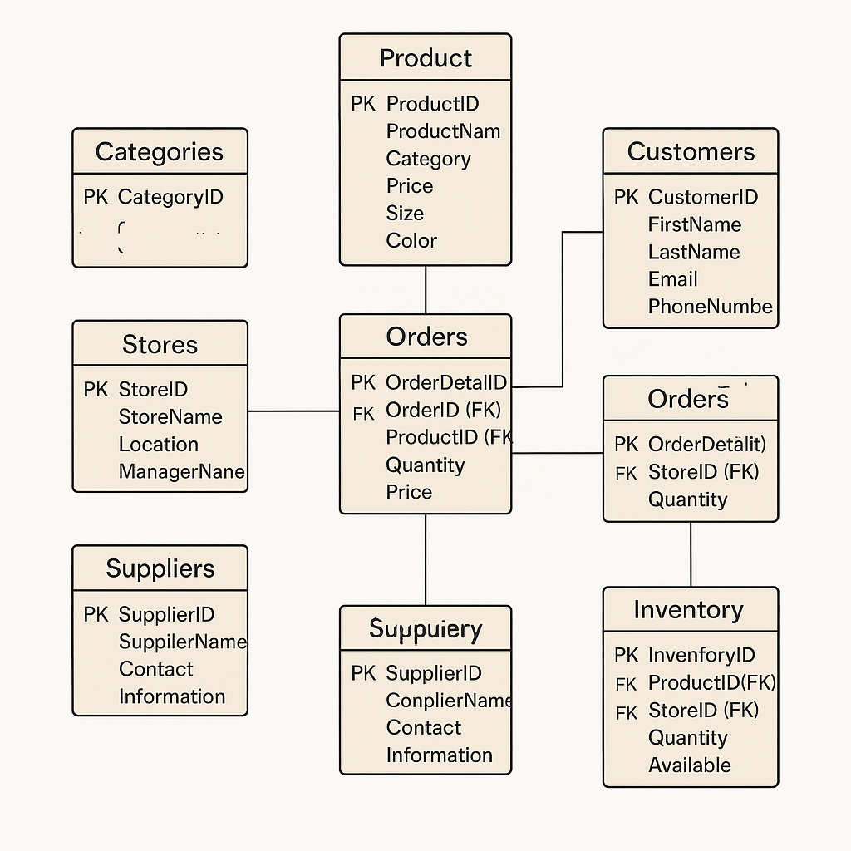

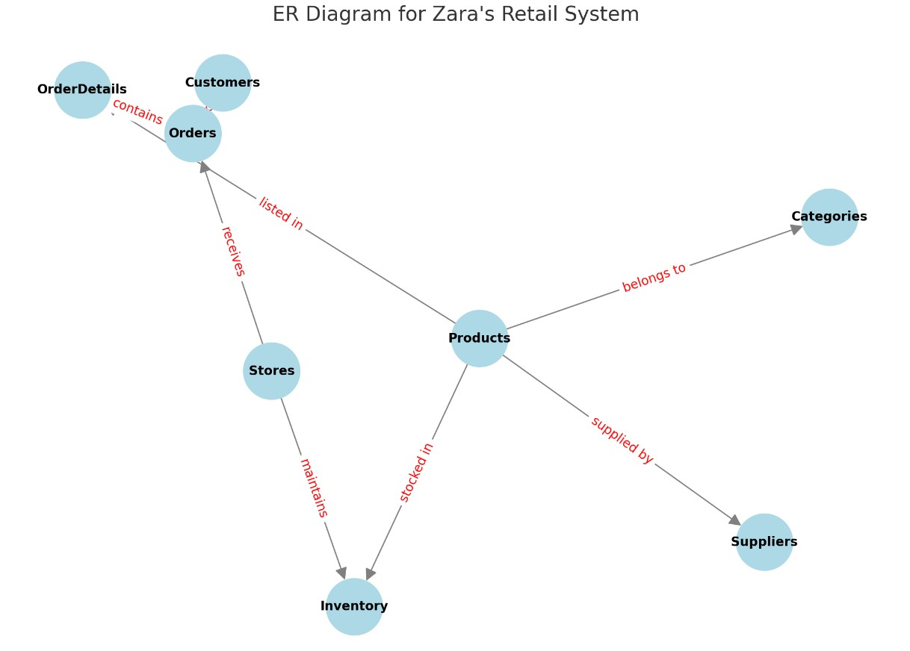

**Conclusion:**

In conclusion we can say that Zara's retail management system is a testament to how innovation and strategic design can redefine global fashion. By mastering fast fashion, Zara delivers trendy, high-quality products at competitive prices, staying consistently aligned with global fashion trends. Its vertically integrated supply chain ensures rapid production cycles, minimizing overstock and waste while maximizing responsiveness to consumer demands.

Zara's commitment to sustainability, omnichannel integration, and data-driven design solidifies its position as a leader in the fashion industry.